**CENTURION UNIVERSITY OF TECHNOLOGY AND MANAGEMENTS**



**Assignment 7**

Course Title: System Integration with Dymola

Course Code: CUTM1022 (0-0-2)

**Submitted to:**

***Dr. Sudhansu Kumar Samal***

*Faculty of*

*School of Engineering & Technology, Bhubaneswar*

**Submitted by:**

Name: Kiran Kumar Malik

Registration no: 200301120128

Branch: B-Tech in Computer Science and Engineering’s

Semester: 4th Sem

Section: C

**Experiment No.: 7**

Create a DC MOTOR package under that create two models

**Requirements:**

OpenModelica software

**Procedure:**

Step 1: Open Openmodelica connection editor

Step 2: Click on New Modelica class, give a new Modelica class name, and give the specialization as package then click on ok. Finally a package created

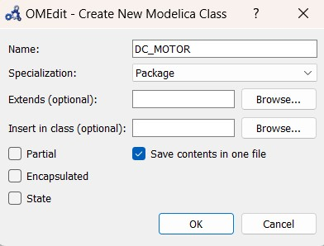

Step 3: Then we have to draw a model

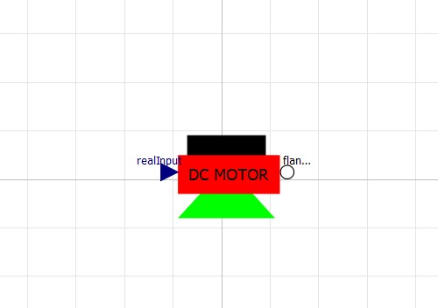

Step 4: I have to create a model under the package, so go to the package which you have created, right click on that package and click on New Modelica Class. Then give the model name then specialization as model, then click on ok

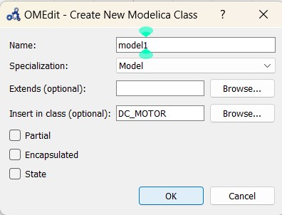

Step 5: The I created a model under a package

Step 6: Then another model I want to create under the last model created, right click on last model, then click on New Modelica Class. Give the model name, give the specialization as model, then click on ok.

Step 7: Then create a model2

